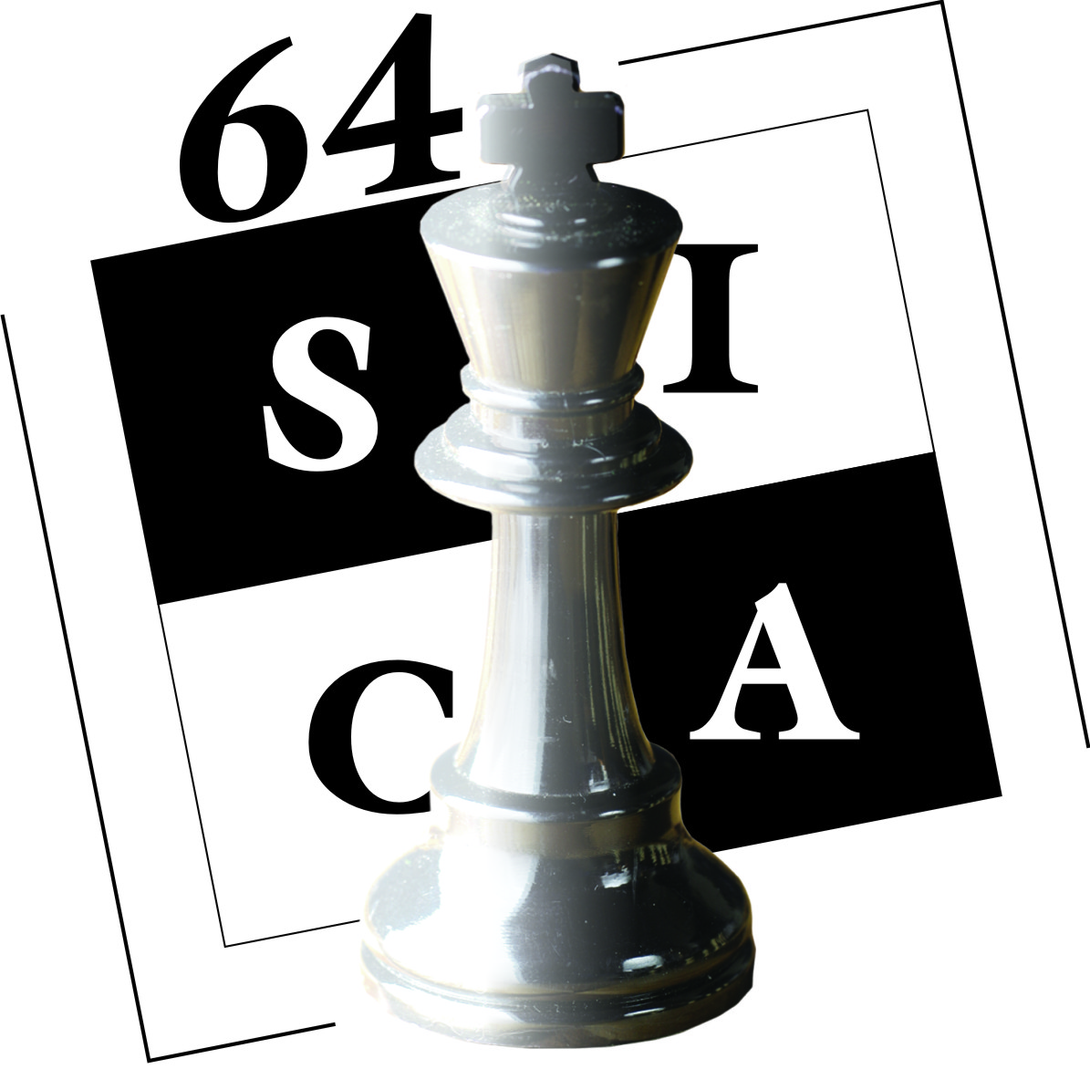

Organized by
64 Squares International Chess Academy
In collaboration with
Chess Federation of Sri Lanka

64 Squares International Chess Academy proudly invites you to the fourth Kandy Open Chess Festival. One of the biggest International Rating Tournaments in Sri Lanka with a prize fund of Rs 300 000 and organized in the Historic Hill Capital in Central Sri Lanka, the organizers expect over 350 chess players including many of the leading players.

Venue-National Institute of Cooperative Development NICD, Polgolla, Kandy.
Schedule
05.08.2013 Arrival
06.08.2013 08.00 am Opening Ceremony
06.08.2013 09.00 am Technical Meeting
06.08.2013 09.30 am Round 01
06.08.2013 03.30 am Round 02
07.08.2013 08.30 am Round 03
07.08.2013 02.30 pm Round 04
08.08.2013 08.00 am Round 05
08.08.2013 02.00 pm Free Afternoon
09.08.2013 08.30 am Round 06
09.08.2013 02.30 pm Round 07
10.08.2013 08.30 am Round 08
10.08.2013 02.30 pm Round 09
11.08.2013 08.00 am Round 10
11.08.2013 02.00 pm Round 11
11.08.2013 07.00 pm Prize Distribution Ceremony
12.08.2013 Departure
Prizes
Champion - Trophy, Gold Medal &Rs. 50,000/=
1st Runner up - Trophy, Silver Medal &Rs. 30,000/=
2nd Runner up - Trophy, Bronze Medal &Rs. 20,000/=
4th Place - Rs. 15,000/=
5th Place - Rs. 10,000/=
6th Place - Rs. 10,000/=
7th Place - Rs. 8,000/=
8th - 10th Place - Rs. 5,000/= each
11th – 15th - Rs. 4,000/= each
16th – 20th - Rs. 3,000/= each
Best Woman Player - Trophy, Gold Medal &Rs. 10,000/=
1st Runner up - Silver Medal, Rs. 6,000/=
2nd Runner up - Bronze Medal Rs. 4,000/=

Category Prizes
Place | Rating Category
 | 1701- 1900 | 1401 - 1700 | 1000-1400 | Unrated
Champion | Rs. 7,000/= | Rs. 6,000/= | Rs. 6,000/= | Rs. 7,000/=
Second Place | Rs. 6,000/= | Rs. 5,000/= | Rs. 5,000/= | Rs. 5,500/=
Third Place | Rs. 5,000/= | Rs. 4,000/= | Rs. 4,000/= | Rs. 4,500/=

Place | Age Group
 | Under 15 | Under 13 | Under 11 | Under 08
Best Player | Rs. 4,000/= | Rs. 3,000/= | Rs. 3,000/= | Rs. 3,000/=
Best Girl | Rs. 3,000/= | Rs. 3,000/= | Rs. 3,000/= | ---------------

In order to encourage our younger plays the 64 Squares International Chess Academy is giving out the following Category Prizes

Age Groups Under 08,11, 13, and 15 Boys and Girls Separate
First Gold Medal
Second Silver Medal
Third Bronze Medal

All participants will be awarded certificates.

Entry Fees
 |  | Rating Category
 | Rated 2400 and above |  | 2000-2399 | 1601-1999 | Rated 1600 and below | Unrated
Entry Fees | Free |  | Rs. 1,000/= | Rs. 2,000/= | Rs. 2,500/= | Rs. 3,500/=

Please deposit relevant amount direct to the bank and handover or email bank slip to following.

Bank - Sampath Bank
Account name - 64 Squares International Chess Academy
Account Number - 0064 1000 2270

Accommodation

All foreign players with more than 2400 ELO rating will be provided accommodation with three meals. Rooms will be given on twin sharing basis.
All those who needs A/C Accommodation has to pay an extra fee of 18 $ per night.
Local outstation players can be accommodated for a nominal charge. Please contact Mr. NuwanWimalasooriya+94 71 630 8129

Foreign Players Please Contact NadithaAmarakoon (+94 775 792 372)
Registration can also be done with the following

Mr. NuwanWimalasooriya 0716308129
Mr.VerochanaPerera (Kurunegala) 0717400249
Mr.P.D.Senanayake (Gampaha) 0777 043825
Mr.Gihan Dinesh (Galle) 0714498167
Mr.JagathKetalawala (Kegalle) 0715130654
Mr.AselaHemantha (Galle) 0772336633
Mr.AsiriPeramunugama (Negambo) 0772273352
Mr.RajivThilakarthne (Anuradhapura, Polonnaruwa) 0776221847
Mr.SumalVithana (Kaluthara) 0714274432
Mr.DulangaDilhan (Matara) 0712535916
Mr.VirajMudalige (Kandy / Matale) 0752082373
Mr.MalithAkalanka (Ambalangoda) 0718740372

The Late Entry fee will be Rs. 500 for the registrations which we get after 30 of July.

Appeals
All appeals/protests should be submitted in writing accompanied by afee of Rs 1000.00.Should the appeal/ protest be upheld the amount will be returned.
All Inquiries to

Mr. LuxmanWijesuriya,  Hon. Secretary,  Chess Federation of Sri Lanka,  107/6, PiyadasaSirisenaMawatha,  Telephone : 0715397829  Colombo 10. | Mr.RajeendraKalugampitiya,  Chairman / CEO,  64 Squares International Chess Academy,  Telephone : 0715601237  64sica@gmail.com  www.e4d4.lk

Visit Us For More Details and Updates - www.e4d4.lk
4th Kandy Open International Rating Chess Championship
From 5th to 12th August 2013

Entry Form

Name …………..............................................................................................................................

Address & Telephone…..……………................................................................................................
………………………………………………...................................................................................................

E-mail:………………………………………………………………. Rating……….............................................

FIDE ID:……………………………… CFSL ID…………………
Club/ School…..…………….........................................
Birthday…………………………… Sex……….......................

We abide by the Rules and Regulations of the event. All the details given above are true to the best of our knowledge.

Signature Date

